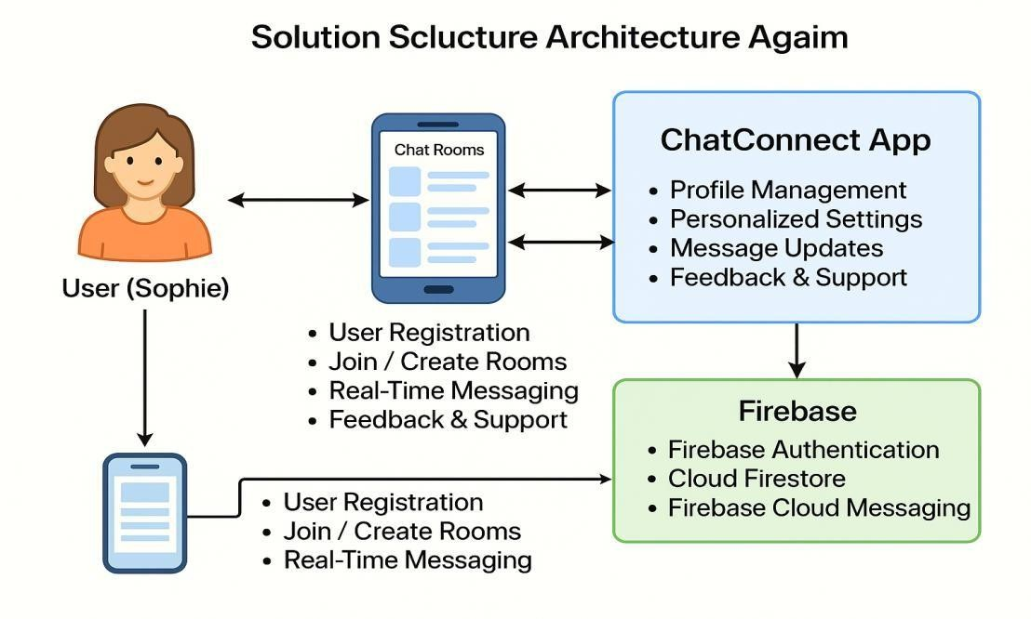
Project

Design

Phase
-
I

Solution

Architecture

Diagram

Solution

Architecture

Diagram:

